**Social Media User Data Analysis**

**Introduction :**

This project aims to analysis the average time spent by users on various social media platforms using Power BI. By leveraging data visualization techniques, the project will provide insights into user behave platform preferences, and peak usage times. The analysis will enable stakeholders to understand trends, optimize content strategies, and enhance user engagement.

The analysis will enable stakeholders to understand trends, optimize content strategies, and enhance user engagement. Through rigorous examination of user engagement metrics, including average time spent and peak usage periods, stakeholders will gain actionable insights to tailor content strategies for each platform effectively. Ultimately, the goal is to empower stakeholders with the tools and insights necessary to make informed decisions and foster meaningful engagement with their target audience across social media platforms.

**Scenario 1 -** Brand Monitoring and Reputation Management: A company wants to monitor its brand reputation and engagement across various social media platforms. By using "Social Pulse: Illuminating the Digital Footprint" with PowerBI, they can track metrics such as mentions, sentiment analysis, and engagement dynamics in real-time. This allows them to quickly identify any negative sentiment or emerging trends and take proactive measures to address them. For instance, they can respond to customer complaints promptly or capitalize on positive feedback by amplifying it through their marketing channels.

**Scenario 2 -** Influencer Marketing Campaign Analysis: A marketing agency is running an influencer marketing campaign for a client. They use "Social Pulse" to track the performance of influencers and gauge the effectiveness of their content in driving engagement and conversions. With PowerBI's visualization capabilities, they can create interactive dashboards that showcase key metrics like reach, engagement rate, and conversion rates across different influencers and social media platforms. This helps them optimize their campaign strategy, identify top-performing influencers, and allocate resources effectively for maximum ROI.

**Scenario 3 -** Event Monitoring and Analysis: An event organizer is hosting a conference and wants to monitor social media activity related to the event in real-time. By integrating "Social Pulse" with PowerBI, they can track the volume of social media mentions, trending topics, and audience sentiment throughout the event duration. This information enables them to measure the impact of their event, identify areas of interest or concern among attendees, and make data-driven decisions to enhance future event planning and execution. Additionally, they can use the insights gathered to engage with attendees, address any issues promptly, and leverage positive feedback to promote future events.

**Technical Architecture:**

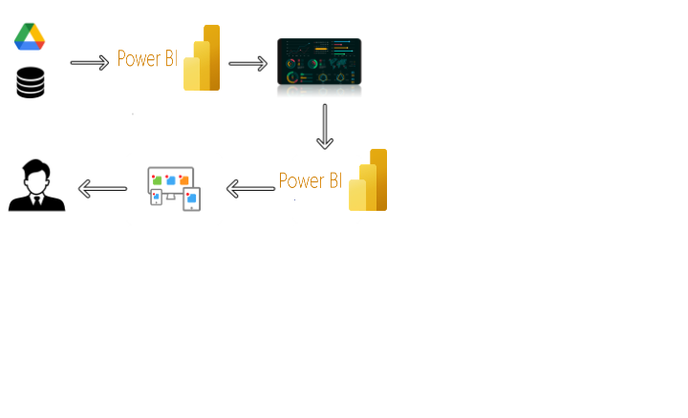

**Project Flow**

To accomplish this, we have to complete all the activities listed below,

* Data Collection & Extraction from Database
  + Collect the dataset,
  + Storing Data in DB
  + Perform SQL Operations
  + Connect DB with Power Bi
* Data Preparation
  + Prepare the Data for Visualization
* Data Visualizations
  + No of Unique Visualizations
* Dashboard
  + Responsive and Design of Dashboard
* Report
  + Responsive and Design of Dashboard
* Performance Testing
  + No of Visualizations/ Graphs
* Project Demonstration & Documentation
  + Record explanation Video for project end to end solution
  + Project Documentation-Step by step project development procedure

**Milestone 1: Data Collection & Extraction from Database**

Data collection is the process of gathering and measuring information on variables of interest, in an established systematic fashion that enables one to answer stated research questions, test hypotheses, and evaluate outcomes and generate insights from the data.

**Activity 1: Collect the dataset**

Please use the link to download the dataset: [Link](https://www.kaggle.com/datasets/imyjoshua/average-time-spent-by-a-user-on-social-media/data)

**Activity 1.1: Understand the data**

Data contains all the meta information regarding the columns described in the CSV files. we have provided 5 CSV files:

1. Social_Media_data

**Column Description for dim_date:**

1. age: The age of the user.

2. gender: The gender identity of the user (Male, Female, Non-binary).

3. demographics: The type of area the user resides in (Urban, Suburban, Rural).

4. interests: The user's primary area of interest or hobby.

5. device_type: The type of device used by the user (Mobile).

6. location:The country of residence for the user.

7. platform: The social media platform where the user spends time.

8. profession: The user's occupation or professional status.

9. income: The yearly income of the user.

10. indebt: Indicates whether the user is in debt (True or False).

11. homeowner: Indicates whether the user owns a home (True or False).

12. owns_cars: Indicates whether the user owns cars (True or False).

**Activity 2: Connect Data with Power BI**

With Power BI, users can seamlessly connect to a wide range of data sources, including databases, cloud services, spreadsheets, and streaming data. This capability allows organizations to consolidate disparate data sources into a single, unified platform, breaking down data silos and enabling holistic analysis.

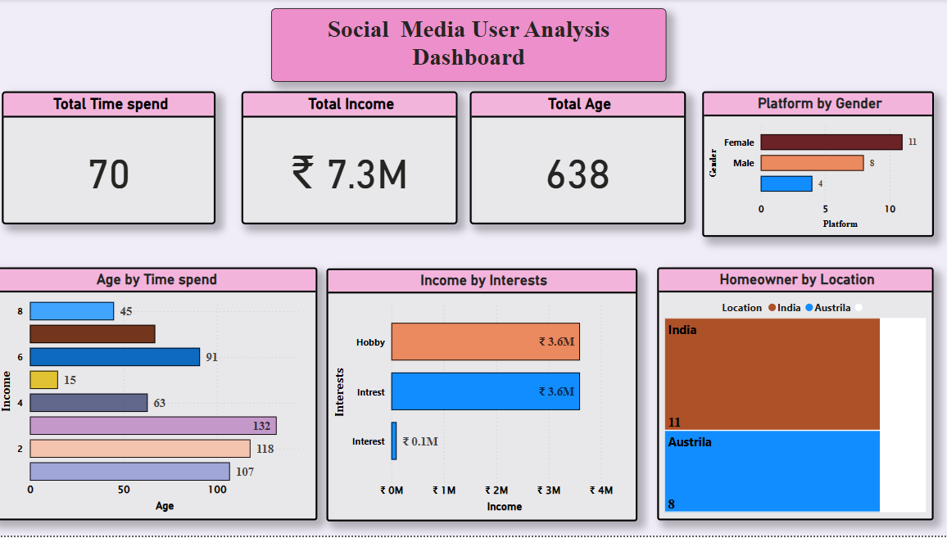

**Milestone 2: Data Preparation**

Data preparation is a critical phase in the data lifecycle, encompassing activities that transform raw data into a format suitable for analysis. This multifaceted process involves several steps including data cleaning, integration, transformation, and enrichment. Data cleaning involves identifying and rectifying errors, inconsistencies, and missing values within datasets to ensure accuracy and reliability.

**Activity 1: Prepare the Data for Visualization**

Preparing the data for visualization involves cleaning the data to remove irrelevant or missing data, transforming the data into a format that can be easily visualized, exploring the data to identify patterns and trends, filtering the data to focus on specific subsets of data, preparing the data for visualization software, and ensuring the data is accurate and complete. This process helps to make the data easily understandable and ready for creating visualizations to gain insights into the performance and efficiency.

**Milestone 4: Data Visualization**

Data visualization is the process of creating graphical representations of data in order to help people understand and explore the information. The goal of data visualization is to make complex data sets more accessible, intuitive, and easier to interpret. By using visual elements such as charts, graphs, and maps, data visualizations can help people quickly identify patterns, trends, and outliers in the data.

**Activity 1: No of Unique Visualizations**

The number of unique visualizations that can be created with a given dataset. Some common types of visualizations that can be used to analysis the performance and efficiency of Social Pulse_ Illuminating the Digital Footprint - Unveiling Social Media Engagement Dynamics include bar charts, line charts, heat maps, scatter plots, pie charts, Maps etc. These visualizations can be used to compare performance, track changes over time, show distribution, and relationships between variables, breakdown of revenue and demographics, workload, resource allocation and location.

**Activity 1.1:** **Age by Time Spent**

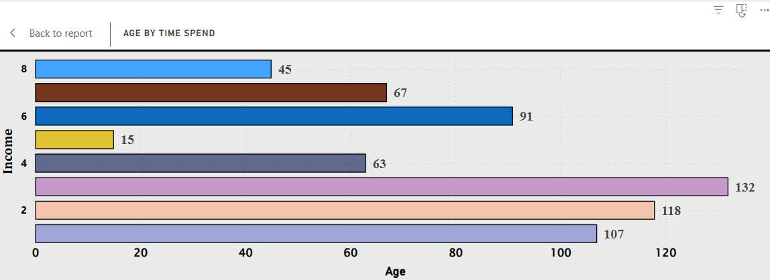

**Activity 1.2: Income By Interest**

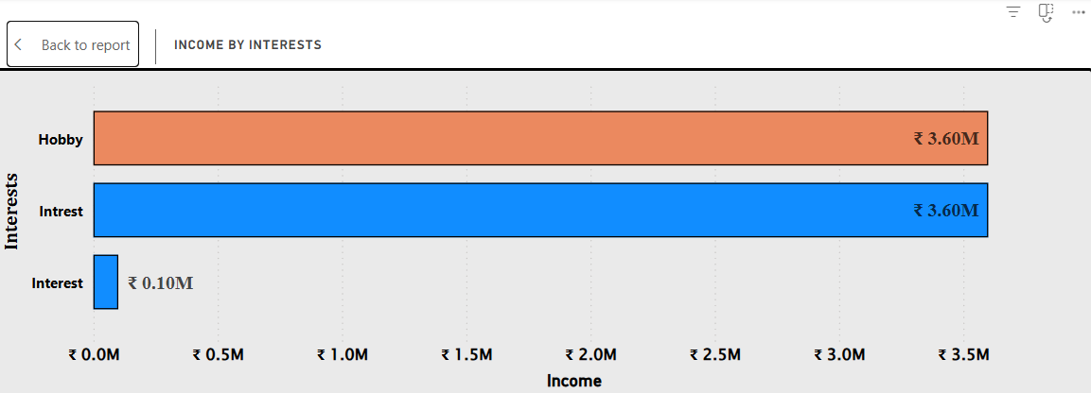

**Activity 1.3: Home Owner By location**

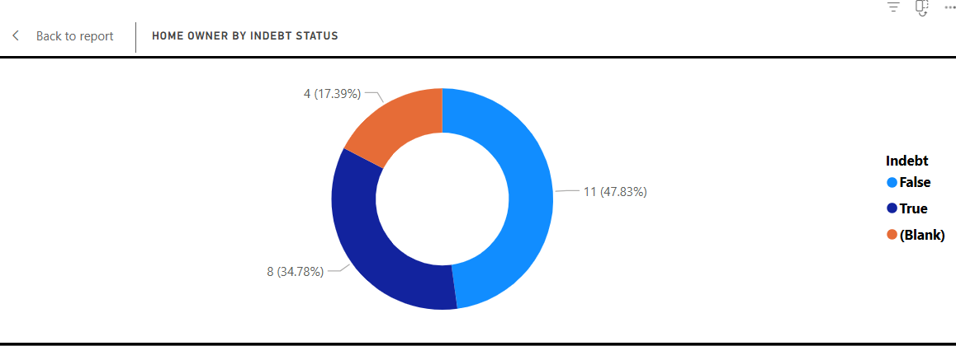

**Activity 1.4: Platform By Gender**

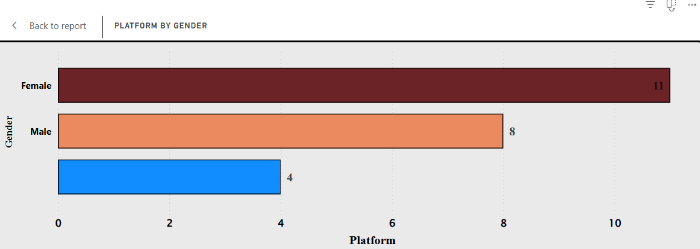

**Activity 1.5: Age By Gender**

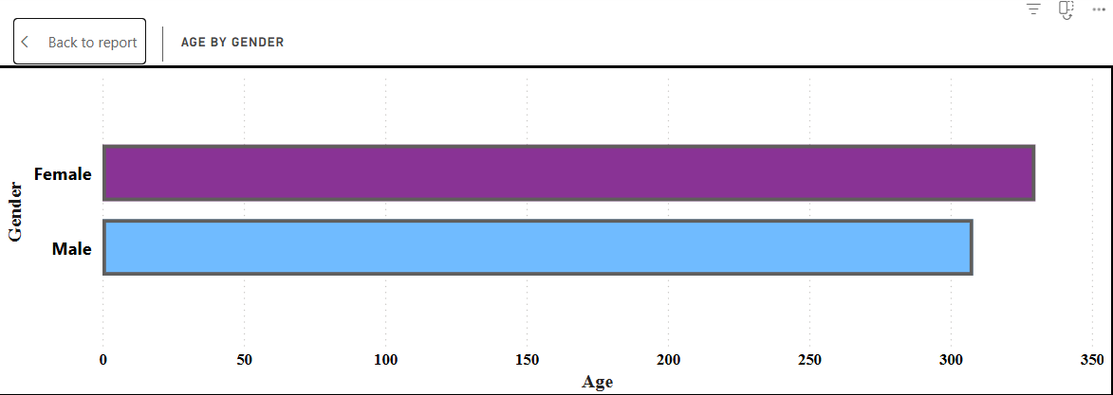

**Activity 1.6: Age by Indebt**

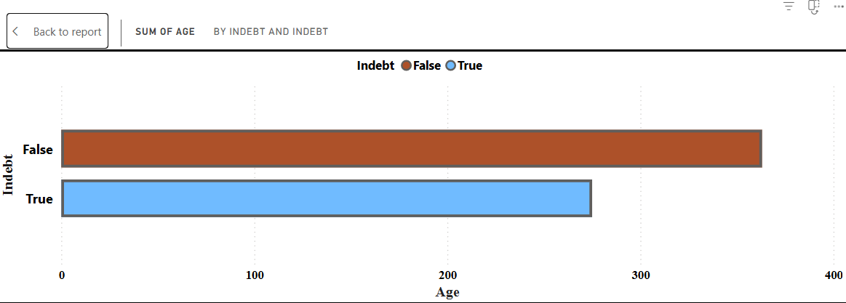

**Activity 1.7: Gender by Interest**

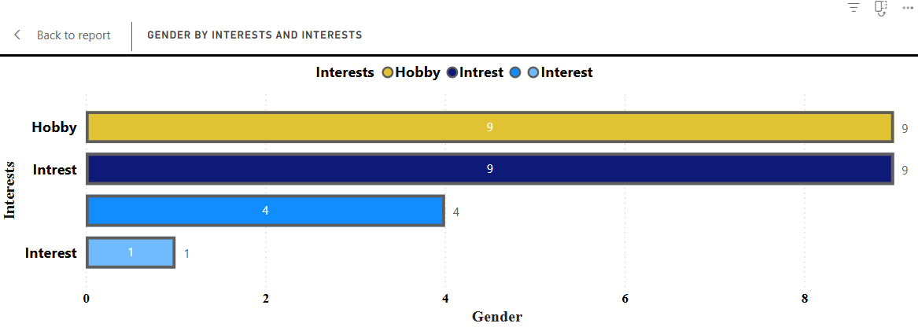

**Activity 1.8: Location By Demographics**

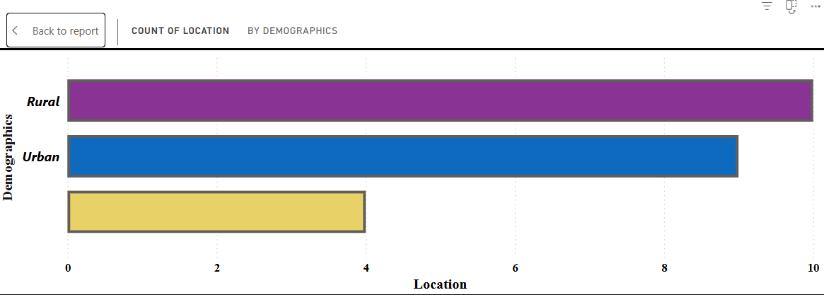

**Activity 1.9: Income By Profession**

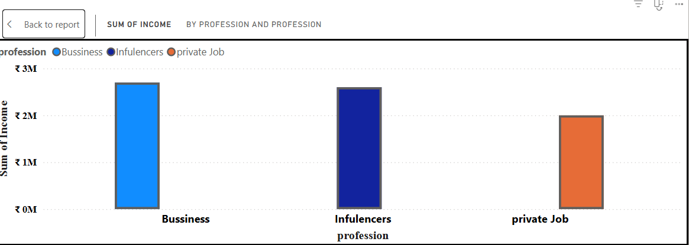

**Activity 1.10: Home Owner by Indebt Status**

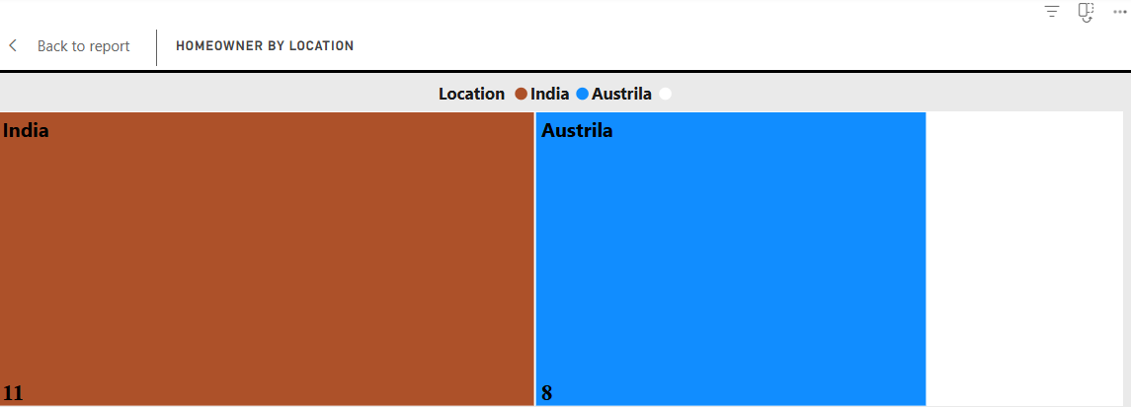

**Activity 1.11 Age by Profession**

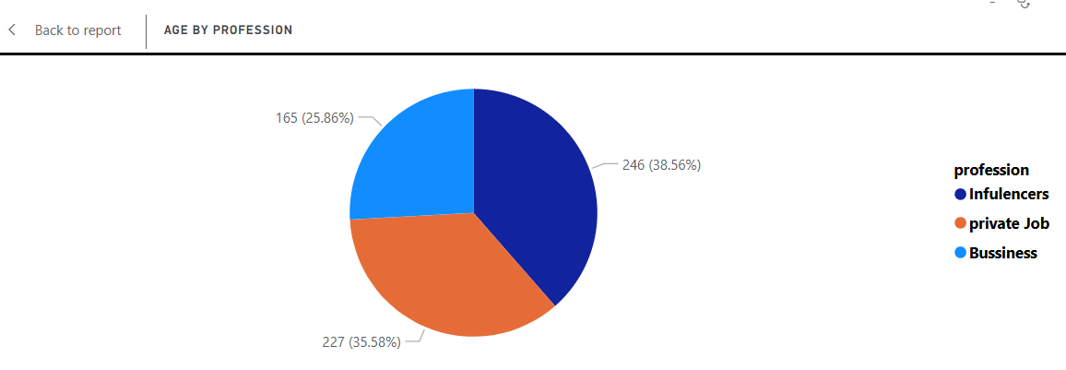

**Activity 1.12: Owns Car by demographics**

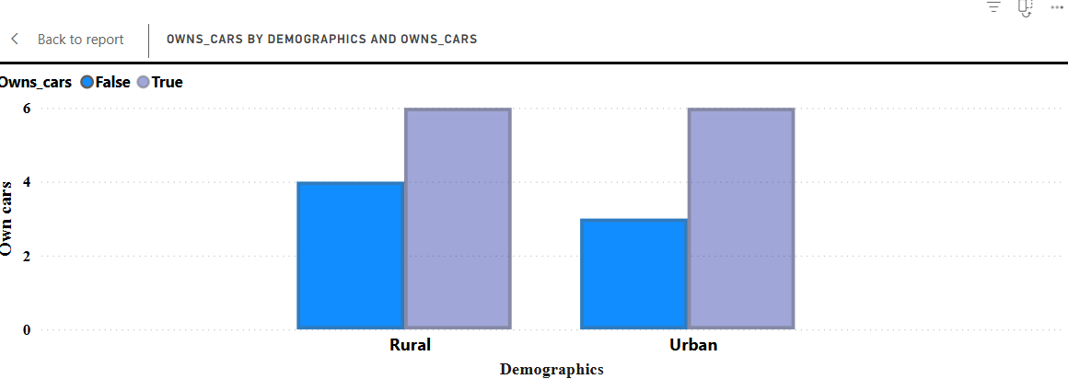

**Milestone 5: Dashboard**

A dashboard is a graphical user interface (GUI) that displays information and data in an organized, easy-to-read format. Dashboards are often used to provide real-time monitoring and analysis of data, and are typically designed for a specific purpose or use case. Dashboards can be used in a variety of settings, such as business, finance, manufacturing, healthcare, and many other industries. They can be used to track key performance indicators (KPIs), monitor performance metrics, and display data in the form of charts, graphs, and tables.

**Activity :1- Responsive and Design of Dashboard**

The responsiveness and design of a dashboard for Social Pulse Illuminating the Digital Footprint Unveiling Social Media Engagement Is crucial to ensure that the information is easily understandable and actionable. Key considerations for designing a responsive and effective dashboard include user-centred design, clear and concise information, interactivity, data-driven approach, accessibility, customization, and security. The goal is to create a dashboard that is user-friendly, interactive, and data-driven, providing actionable insights to improve the performance and efficiency of Social Pulse Illuminating the Digital Footprint Unveiling Social Media Engagement.

Once you have created views on different sheets in Power Bi you can pull them into a dashboard.

**Milestone 6: Report**

A data report is a way of presenting data and analysis in a narrative format, with the goal of making the information more engaging and easier to understand. A data story typically includes a clear introduction that sets the stage and explains the context for the data, a body that presents the data and analysis in a logical and systematic way, and a conclusion that summarizes the key findings and highlights their implications. Data Report can be told using a variety of mediums, presentations, interactive visualizations, and videos.

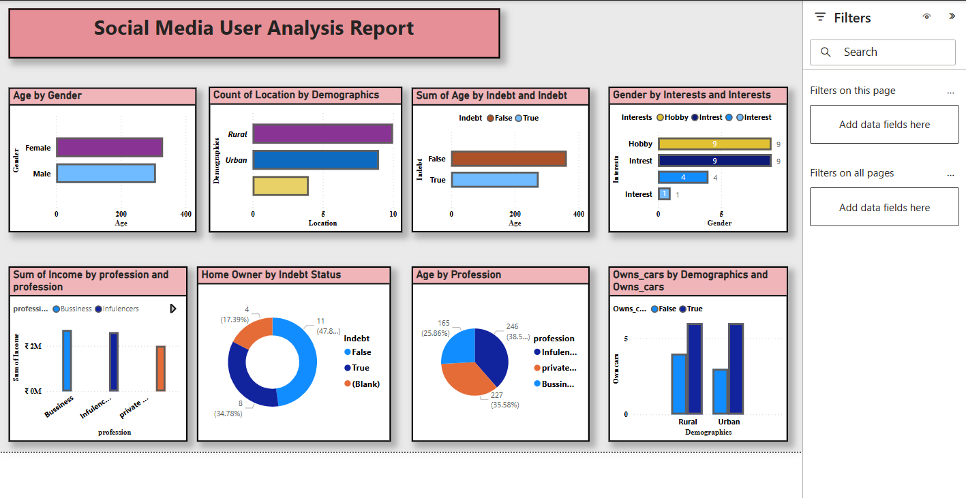

**Milestone 7: Performance Testing**

Performance testing is a crucial aspect of software development aimed at evaluating the speed, responsiveness, stability, and scalability of an application under various workload conditions. It involves simulating real-world usage scenarios to assess how the system behaves and performs under stress, peak loads, or normal conditions.

**Activity 1: Utilization of Data Filters**

The utilization of data filters plays a pivotal role in streamlining information processing and analysis across various domains. By selectively extracting or excluding specific data points based on predefined criteria, filters enable efficient data management and enhance decision-making processes.